Updated help file for 2014
Trevor A. Branch, 24 June 2014
All figures produced during the 24-27 June 2014 meeting in Seattle, Washington, are contained in the file “2013_07 Portland meeting scripts.r”. Typically how the code is organized is with a directory containing all the .r code, and subdirectories \figs where the .pdf figures are saved, \levfiles containing the .lev files, \gridfiles containing the .grid files, \tables where the .csv outputs are saves. One final directory, the \arc directory, contains a subdirectory for each set of model evaluations, including the all-important lab.rep files, e.g. “\arc\base2010sqrtns\base2010sqrtns_h1m1M1O2C2a1_lab.rep”.
The code works by first reading in all of the lab.rep files for a particular model run (all lab.rep files in a directory) and saving these in a list, e.g. data.base2010ns. This takes a few minutes. All subsequent code uses these lists and runs quickly (1-5 seconds).
The meeting script typically sources the R code file and then runs a function in that code, passing it one of the data lists of objects.
There is a .zip file containing all lab.rep and associated files, and a .zip file containing just the .r files.

R viewer for CCSBT code, 2011
Trevor A. Branch & Ana Parma, 9 June 2011
In this help file I describe each R function and include an example of the output graphic expected to be produced.

Background
The R viewer code is intended for graphical visualization of model fits to the SBT data. It produces fits to CPUE data, survey data, tagging data, length frequencies, age frequencies and other plots commonly used as diagnostics. At the core of the viewer code is the reading in of the _lab.rep files produced from each individual model run (i.e. with a single value for M, M10, steepness, omega, etc.).
The underlying basis for the R viewer code is the CCSBT assessment program (current version sbtmod24.tpl = sbtmod24.exe) which runs a single assessment model. Main24.tpl=main24.exe calls sbtmod24 multiple times (180 times for current grid structure) to run a series of these assessment models across combinations of parameters (M, M10, steepness, omega, etc.). Each run of main produces a file ending with “_lab.rep” (“labeled report”). Then sample_v4.tpl=sample_v4.exe resamples these runs to produce a grid containing 2000 random draws from these runs.
The lab.rep files are found in subdirectory /arc/base5hsqrt (for example). There are 180 such files in the 5h version of the code (5h = 5 levels of steepness), each weighing in at 405 KB.

Philosophy
It takes a non-significant amount of time to read in the data from each of the lab.rep files, thus R code that reads in the data every time it runs will be slow (of the order of a few minutes). For this reason, we prefer to read in the data once into a single massive list containing all the lab.rep files. Each individual file is read in using the command readList which is available from the PBSmodelling package, downloadable from CRAN. Previous reports have found this package does not work under Linux. The lab.rep files are specifically designed for the readList command, formatted in such a way that they can be read in with labels intact, and with data in vectors / matrices etc. automatically detected.
Where graphics are based on the full grid (either 180 files or the 2000 in the grid), the code is designed to (1) read in all lab.rep files from a specified subdirectory (using the ls() command, so literally EVERY lab.rep file in the directory is read in), (2) create a list containing all the data in every object, and (3) pass this list to each R graphics and other functions, where all the lab.rep files are needed. The reading in process needs only be done once, which speeds up running of the functions from minutes to seconds.

Packages needed
You will need to install PBSmodelling from the CRAN archives. In R, install packages, select a mirror, then choose PBSmodelling, then Load Package.
Also you will need to install gplots for the colors in some of the plots.

Files
aaaTB11 June R viewer examples.r = file that contains complete R code calling the R functions for the examples below. This is the “how to use the code” file.
aaaReadme for R viewer for CCSBT.doc = this document description of R viewer
arc\base5hsqrt\ = directory containing the lab.rep files used in the examples (replace with whatever directory you have files in, remember R requires \\ wherever \ is written).
example_lab.rep = copied lab.rep file in the R directory for easy access and plotting.
\\figs = expects a subdirectory “figs” to send pdf output graphics to (to avoid cluttering the R code directory
\\tables = expects a subdirectory “tables” to send tables produced

Reading in the lab.rep files
function “get.all.files.r”. This compact function reads in all the data from all the lab.rep files in a directory using a function in PBSmodelling and returns them in a list. Running this on a directory with 180 lab.rep files took about 2 minutes on my machine (I do save the resulting workspace) and produced an .Rdata file of 25 MB.
data.base5hsqrt <- get.all.files(directory= “arc\\base5hsqrt")
To view the first file in the list, type: data.base5hsqrt[[1]]
To see what names are allowed, type: names(data.base5hsqrt[[1]])

Reading in the *.prj file
Function “get.prj.r”. This function reads *.prj file, which contains all the variables passed to the projection code from the conditioning code, and samples results using *.lev file to get distributions of several variables over the sampled grid.

Document format
I present a series of figures with the R code below them. They should be self-explanatory.

Functions not described in this help file
“Array of values.r” This loops through all combinations of parameter values (h, M, etc.) to produce a list of file names, and can be used to extract values from the .par files, for example. Largely superseded by the data in the lab.rep files, and not updated (the variables selected and number of levels within each have changed).
“compare tagging fits pooled.r”: allows for overplotting of tagging data fits from multiple model runs.
“PlusGroup9by3.r”

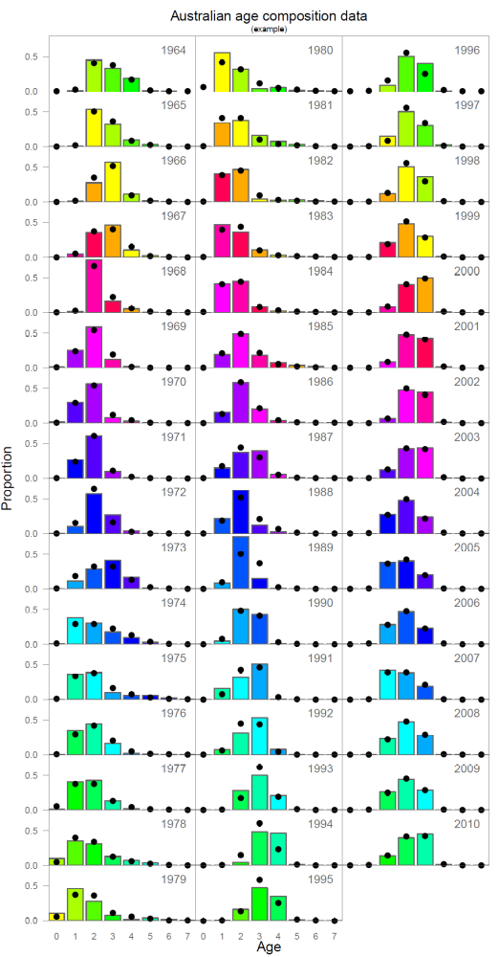
Fit of the model to the Australian age composition data for a single lab.rep file. The colors follow cohorts.
source("AussieAgeFits.r")
pdf("figs\\Fig 1 AussieAge.pdf",width=6, height=11.5)
AussieAgeFits(labrep.file="example_lab.rep",case_label="example")
dev.off() #to close pdf file, when errors occur type this in a few times.

Note: this graphics file still assumes you specify a named lab.rep file and directory instead of the read in list of objects containing all lab.rep files.

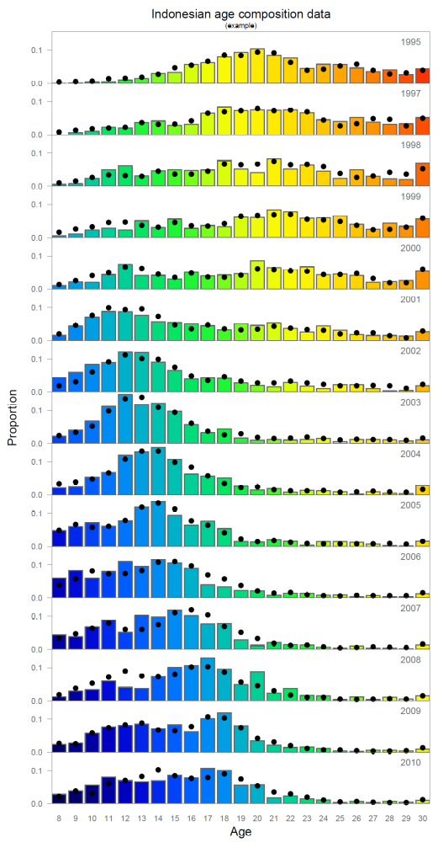
Example model fit to the Indonesian age composition data.
source("IndoAgeFits.r")
pdf("figs\\Fig 2 IndonesianAge.pdf",width=6, height=11.5)
IndoAgeFits(data.object=data.base5hsqrt[[1]],case_label="example")
dev.off()

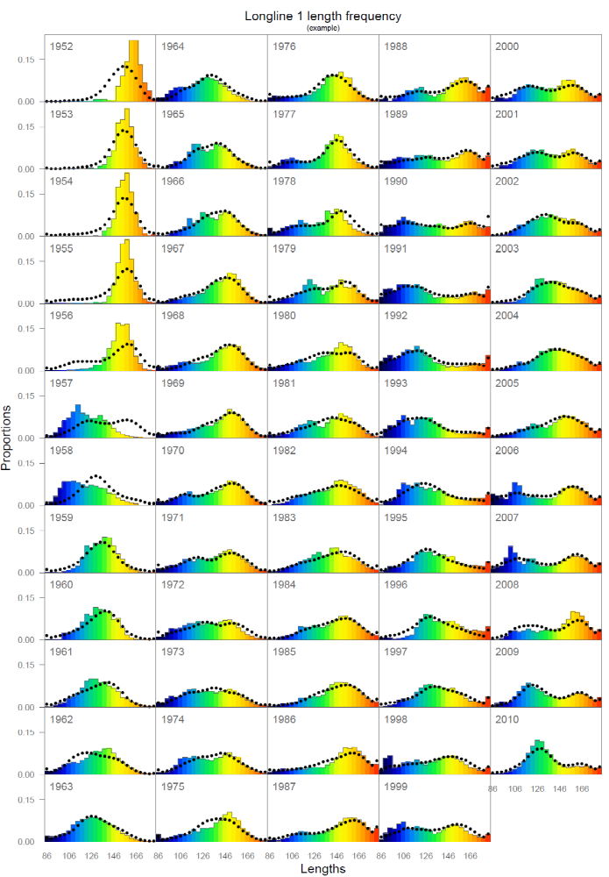
Fits to lengths of LL1.
source("LengthsLL1.r")
pdf("figs\\Fig 3 LengthsLL1.pdf",width=8, height=11.5)
LengthsLL1(labrep.file="example_lab.rep",case_label="example")
dev.off()

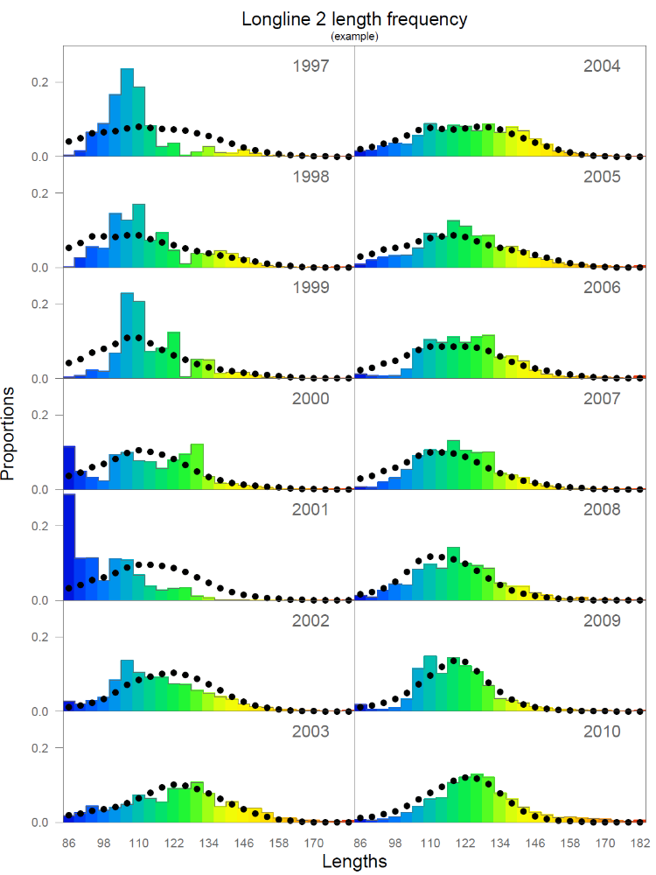
source("LengthsLL2.r")
pdf("figs\\Fig 4 LengthsLL2.pdf",width=6, height=8)
LengthsLL2(labrep.file="example_lab.rep",case_label="example")
dev.off()

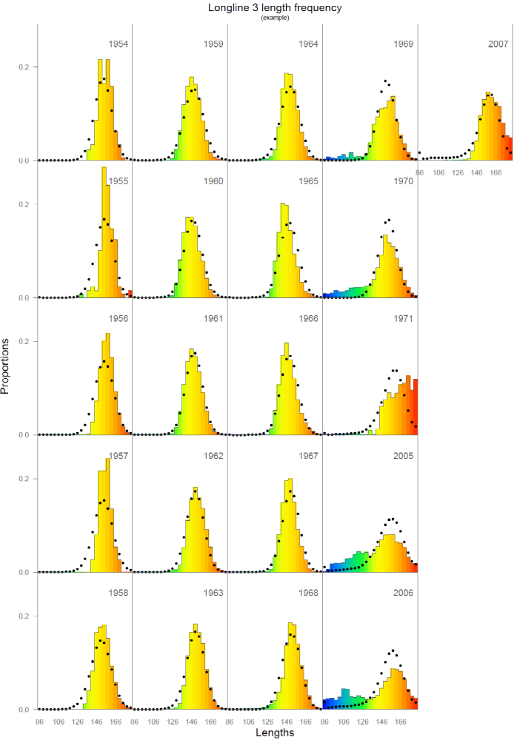
source("LengthsLL3.r")
pdf("figs\\Fig 5 LengthsLL3.pdf",width=8, height=11.5)
LengthsLL3(labrep.file="example_lab.rep",case_label="example")
dev.off()

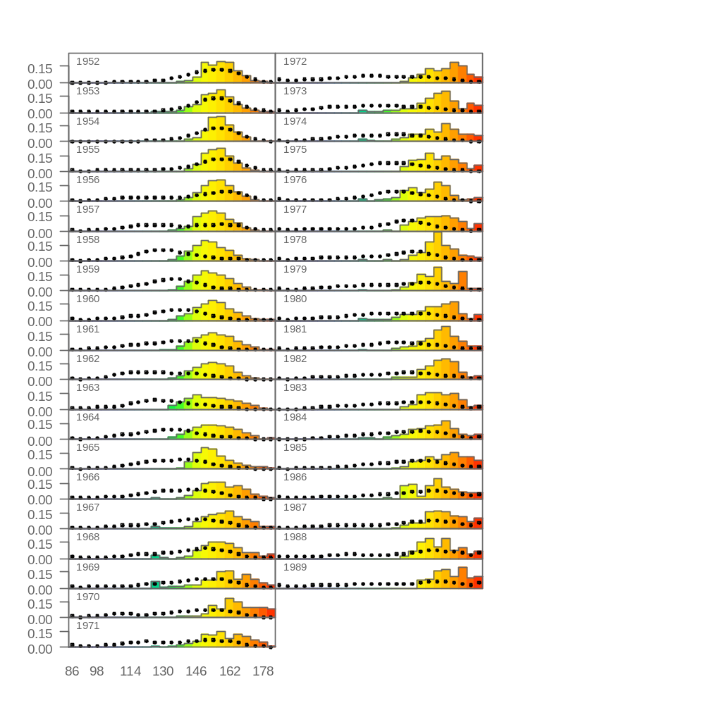

source("LengthsLL4.r")
pdf("figs\\Fig 6 LengthsLL4.pdf",width=5, height=11.5)
LengthsLL4(labrep.file="example_lab.rep",case_label="example")
dev.off()

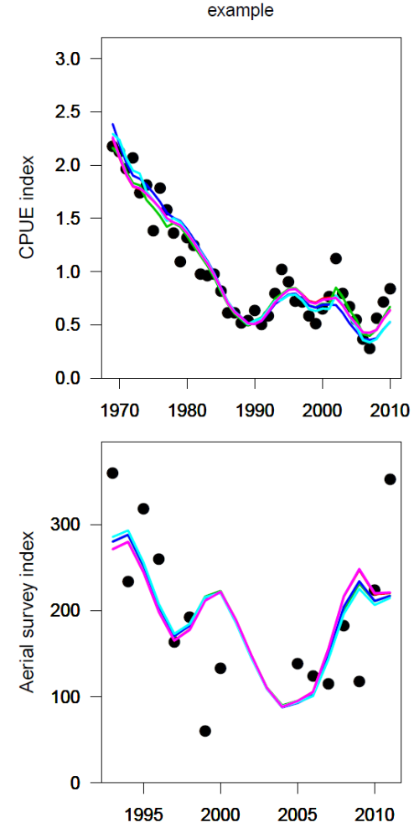
source("Compare fits.r")
pdf(file="figs\\Fig 7 SurveyIndexFits.pdf",width=4,height=8)
compare.fits(compare.objects=data.base5hsqrt[1:5],lab.cex=1.1,case_label="example", legend=names(data.base5hsqrt[1:5]))
dev.off()

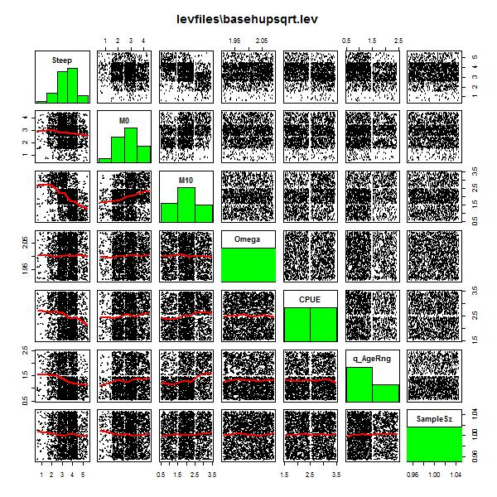
Shaded plot, showing how many times each of the 180 runs are resampled to form the grid of 2000. Requires .lev file which is created after running sample_v4 and resides in arc\grids for example. I usually copy it in the R directory.
Note that h values are higher in this grid than used in 2009.

source("ShadedPlots.r")
jpeg(file="figs\\Fig 8 Shaded basehupsqrt.jpg", width=600,height=600)
plot.lev("levfiles\\basehupsqrt.lev")
dev.off()

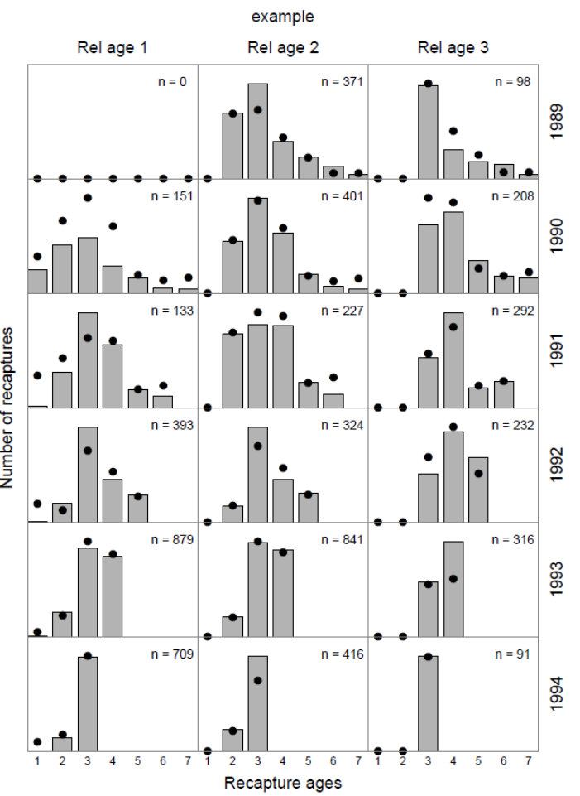
Fits to tagging data combined over tagging groups.
source("Tagging fits combine tagger groups.r")
pdf("figs\\Fig 9 Tagfits combine taggers.pdf",width=6,height=8)
tagging.fits(data.object = data.base5hsqrt[[1]],case_label="example")
dev.off()

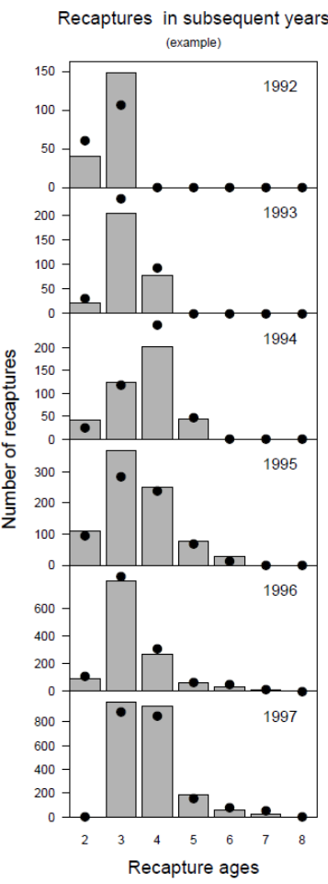
Pooled tagging data and model fits.
source("Tagging fits pooled.r")
pdf("figs\\Fig 10 Tagfits pooled.pdf",width=3,height=8)
tagging.fits.pooled(data.object = data.base5hsqrt[[1]], ages=2:8, years=1992:1997,case_label="example")
dev.off()

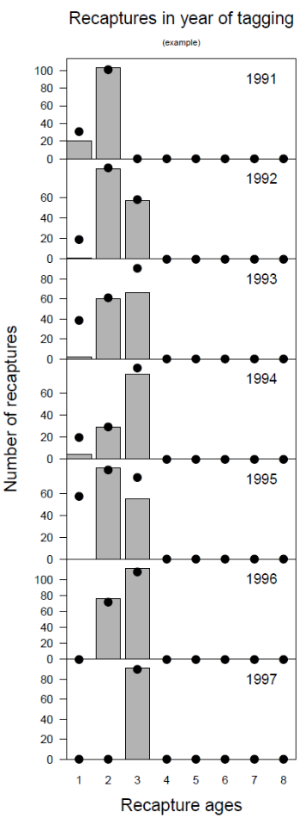
Recaptures in same year.

source("Tagging fits same year.r")
pdf("figs\\Fig 11 Tagfits same year.pdf",width=3,height=8)
tagging.fits.same.age(data.object = data.base5hsqrt[[1]], ages=1:8, years=1991:1997,case_label="example")
dev.off()

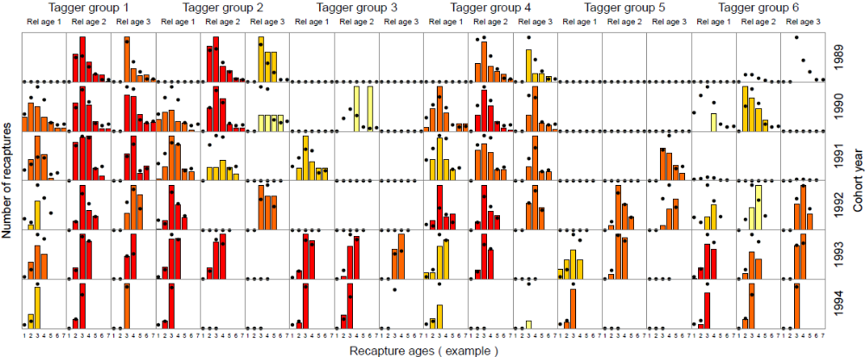
Fits to tagging data, all. Colors represent sample sizes, with darker red implying more samples and lighter colors fewer samples.

source("Tagging fits subsequent.r")
pdf("figs\\Fig 12 Tagfits subsequent.pdf",width=12,height=5)
tagging.fits(data.object = data.base5hsqrt[[1]],case_label="example")
dev.off()

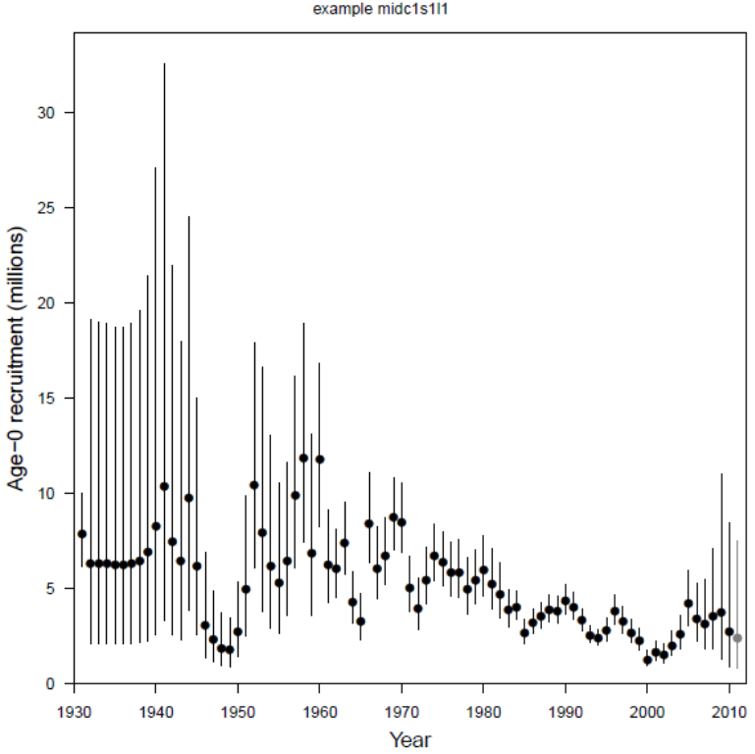
This plot calculates recruitment plus lognormal 95% CI intervals, but this requires an .std file, which is only created on request (needs calculation of the Hessian which is time consuming and therefore omitted when running the grid).

source("Recruitment.r")
pdf(file="figs\\Fig 13 Recruitment v3.pdf",width=8,height=8)
x <- plot.recruitment(std.file="std files\\sbtmod24.std", labrep.file="std files\\sbtmod24_lab.rep",case_label="example midc1s1l1")
dev.off()

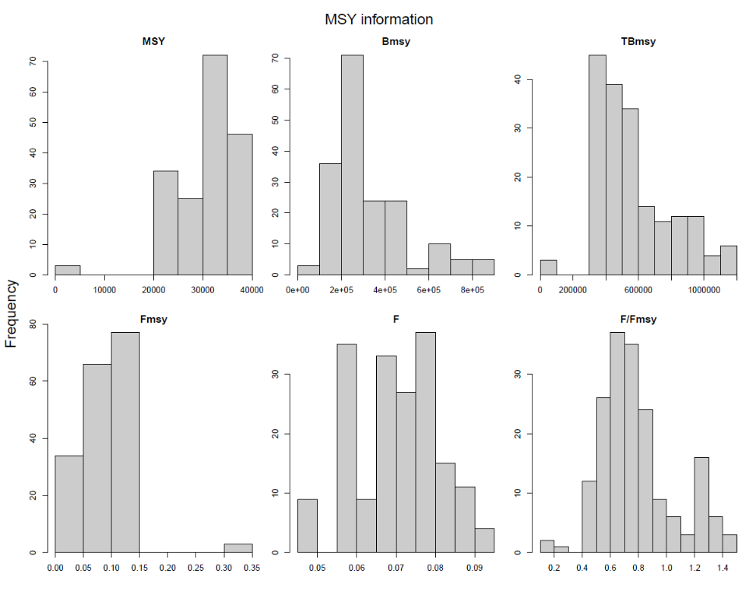
Figure showing Bmsy (spawning biomass), TBmsy (total biomass), Fmsy (for ages 2-15), F, and MSY.

source("MSY values.r")
pdf(file="figs\\Fig 14 MSY.pdf",width=10,height=8)
MSY.vals(data.objects=data.base5hsqrt,label="")
dev.off()

Table showing the likelihood components for the first few model runs that go into the grid (the full output is 180 lines long, one for each model run). The last two columns are the sum of the NLLs and the objective function minimized in the model (includes penalties?).

source("TableLikelihoodComponents.r")
x <- likelihood.table(data.objects=data.base5hsqrt)
write.csv(x,file="tables\\likelihoods.csv")

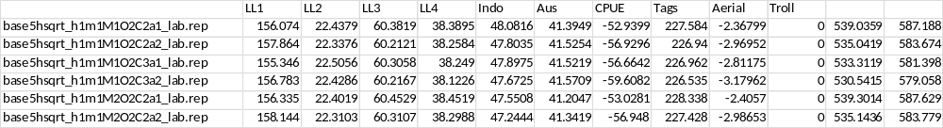

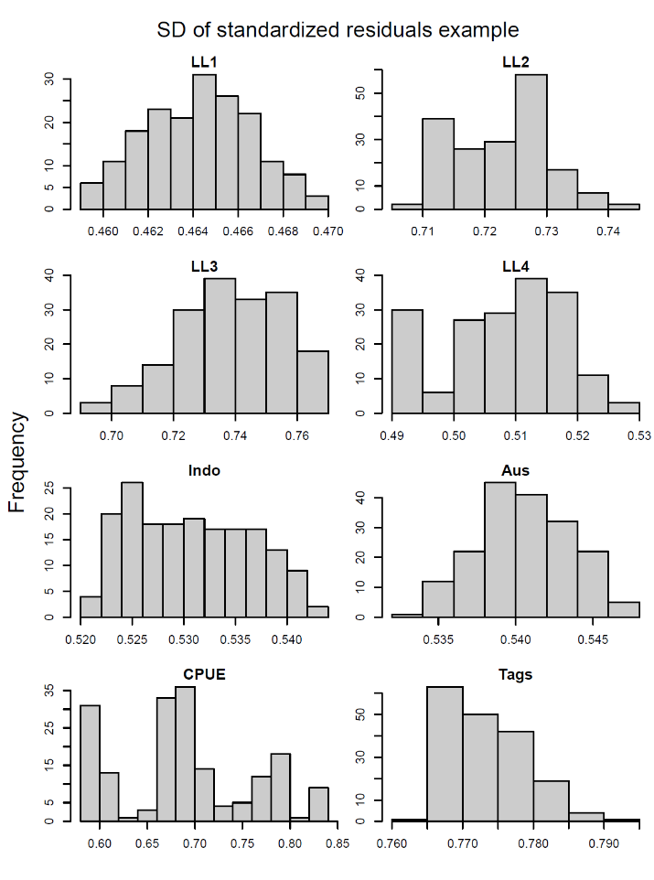
SD of residuals between model fit and data for the different components. Each item in the frequency is the number of model runs out of 180.

source("SD residuals.r")
pdf("figs\\Fig 15 SD resids.pdf",width=6,height=8)
hist.SD.resids(data.objects=data.base5hsqrt, label="example")
dev.off()

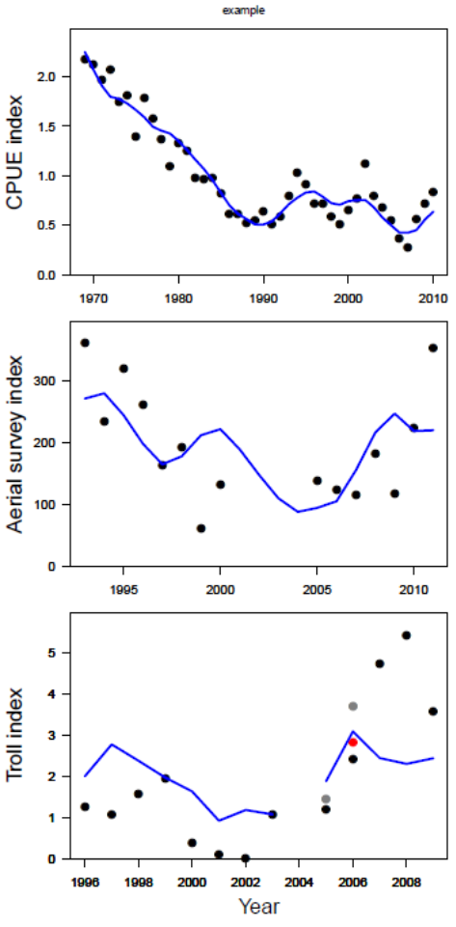
Model fits to the time series, same as Figure from “compare.fits.r” except this plots a single model run, and also includes the fits to the troll data. For the troll data the different colors indicate 2 or 3 separate index values in those years (I think).

source("SurveyIndexFits.r")
pdf(file="figs\\Fig 16 SurveyIndexFits.pdf",width=4,height=8)
fit.all(data.object=data.base5hsqrt[[1]],lab.cex=1.1,case_label="example")
dev.off()

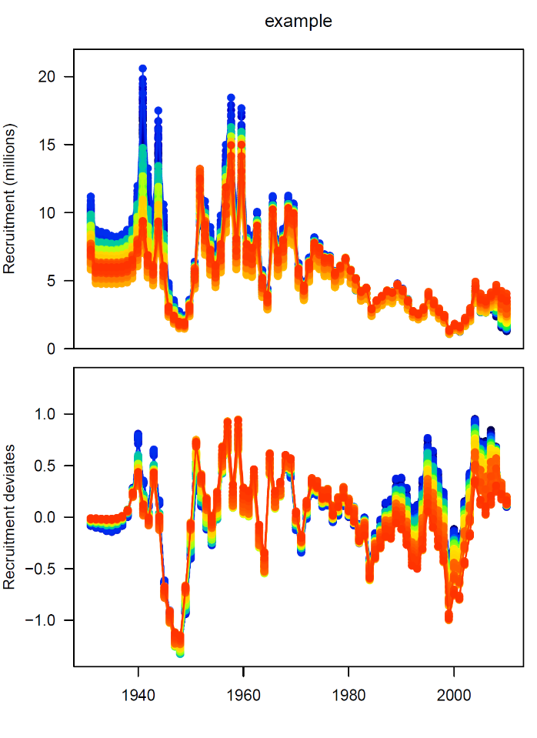
Overplotting all recruitment time series from all of the 180 model run cells. Colors are from a continuum thus each individual cell is not really recognizable.

source("Compare recruitment.r")
pdf(file="figs\\Fig 17 Compare recruitment.pdf", width=6, height=8)
compare.recruitment(compare.objects=data.base5hsqrt[1:180],label="example",legend=NULL, R.ylim=c(0,22))
dev.off()

pdf("figs\\Fig 18 Plus Group9by3.pdf",width=11.5,height=6)
compare.plus.groups2(compare.objects=data.base5hsqrt[1:9],ylim=c(0,1))
dev.off()

Examining whether there are excessive numbers of predicted plus group fish in the model for 9 runs. Top row shows numbers at age in 2008. Middle row shows the estimated selectivity for the Indonesian fishery (which operates mostly on older fish). Bottom row shows the values for natural mortality at age. This issue came up in 2009 and has not really been re-examined since.

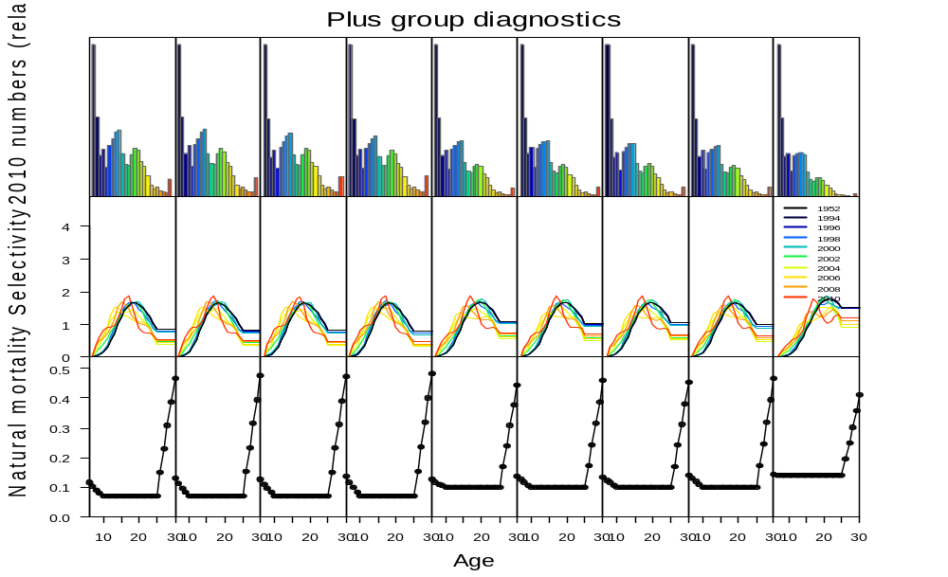

source("PlusGroup9by3.r")
pdf("figs\\Fig 18 Plus Group9by3.pdf",width=11.5,height=6)
compare.plus.groups2(compare.objects=data.base5hsqrt[1:9],ylim=c(0,1))
dev.off()

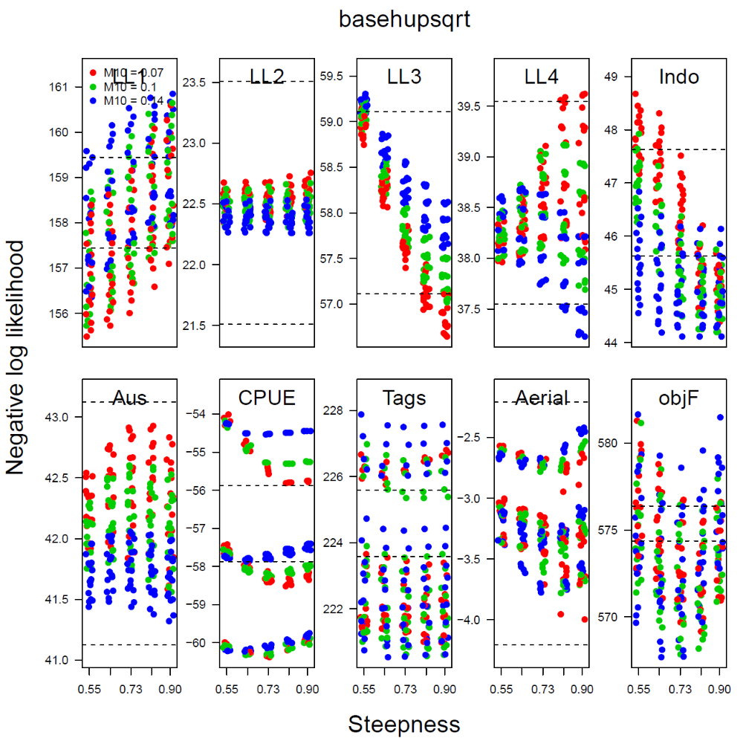
source("get.all.files.r")
data.base <- get.all.files("arc\\basehupsqrt")
source("TableLikelihoodComponents v2.r")
nll.table.base <- likelihood.table2(data.objects = data.base)
source("PlotNLLComponents.r")
pdf("Balifigs\\Fig 1 Compare NLLs excluding LL3 2005-2007.pdf")
plot.NLL.by.steepness(nll.table.base,caption="basehupsqrt")
dev.off()

